Rotohoe ki Ngongotahā
Reeme St Reserve, Ngongotahā
Saturday 20 April 2024

TEAM EVENT WAIVER & BIOSECURITY PLAN ACCEPTANCE FORM
Team Name: __________________________________________________________________
Club Name: ___________________________________________________________________
Race/Division entered: __________________________________________________________
I declare that:
- My accepted entry will not be transferred to another entrant.
- In the event of any “act of god” conditions causing a cancellation of the event, my total entry fee is not transferable or refundable.
- I acknowledge that there are risks involved with Waka Ama and fully realise the dangers of participating in an event such as this and fully assume the risks associated with such participation and my wellbeing during the event.
- I understand and agree that situations may arise during the event, which may be beyond the immediate control of officials or organisers, and I must continually participate in a manner that does not endanger either myself or others.
- Neither the organisers, the sponsors nor other parties associated with the event shall have any responsibility, financial or otherwise, for any risk incident that might arise, whether or not by negligence, from any direct or indirect loss, injury or death that might be sustained by me or any other party directly or indirectly associated with me, from my intended or actual participation in the event or its related activities.
- I authorise my name, voice, picture and information on this entry form to be used without payment to me in any broadcast, telecast, promotion, advertising, or any other way pursuant to the Privacy Act 2020.
- I agree to comply with the rules, regulations and event instructions of the Rotohoe Series.
- I consent to receiving medical treatment which may be advisable in the event of illness or injuries suffered during the event.
- I can confirm that I can swim 50 Metre/ OR if I cannot swim 50 Metres I will wear a PFD during the race.

Declaration:
I hereby declare my understanding and acceptance of the event waiver and statements within.
I also declare that I have read the Rotohoe Biosecurity Plan and together with the rest of my team, have carefully followed the instructions provided in it.

Kaihoe: Full name | Date of Birth | Medical conditions | Signed

Rotohoe Biosecurity Plan
This to prevent the spread of any invasive species, but in particular, the Freshwater Gold Clam (Corbicula fluminea) by our event – both by our event equipment and by participants’ equipment.
All kaihoe are expected to follow best practice Check Clean Dry (CCD) procedures as set out in the Waka Ama NZ Freshwater Gold Clam Info Sheet (see next page).
This includes removing bungs from all waka and draining bulkheads/hulls of W1 and W6. If it is not possible to completely drain bulkheads/hulls, bleach must be added. Kaihoe will be required to sign a waiver indicating that they have followed the carried out appropriate treatment of waka, PFDs and hoe.
Furthermore, kaihoe participating in the Rotohoe Series will also be assessed as being at one of three levels of risk, depending on the waterway they and their waka & equipment have been used on.
High risk
Kaihoe coming from ‘high risk’ areas i.e. anywhere along the Waikato River will be identified through the registration process and biosecurity procedures will be communicated via email in the weeks leading up to the race. All kaihoe must self-identify if their waka has been on the Waikato River in the 30 days prior to the Rotohoe race and follow the following procedures:
1. Any waka from “the clam zone” (i.e. anywhere along the Waikato River) will be required to be:
- washed by Te Arawa Lakes Trust biosecurity team using high-pressure wash facilities located at the Rotohoe race venue (Reeme St Reserve) from 7.30am – 12pm on race day and
i. After being washed have waiver signed off by Te Arawa Lakes Trust biosecurity team confirming that waka have been washed following appropriate procedures
or
- washed at The Wash Place located at 338 Te Ngae Road and after being washed at The Wash Place:
i. Scanned the QR Code displayed within each wash bay at The Wash Place using a mobile device and filled out the online form that opens on their mobile device; or
ii. Taken a video on a mobile device showing that they washed their craft at The Wash Place
4. Where possible hire equipment from Rotorua clubs.
5. Follow good practice (CCD) on return home.
Medium Risk
Any waka from other North Island lakes, rivers, and estuaries that contain a large amount of freshwater – i.e. Whanganui, Whakatane are to follow ‘Clam specific CCD’ instructions for entry to Te Arawa Lakes (including Lake Rotorua). For return home ‘Clam specific CCD’ is also required.
Low Risk
Any waka and equipment used on Te Arawa Lakes & from saltwater locations with minimal freshwater input. CCD procedure is recommended as following best practice.
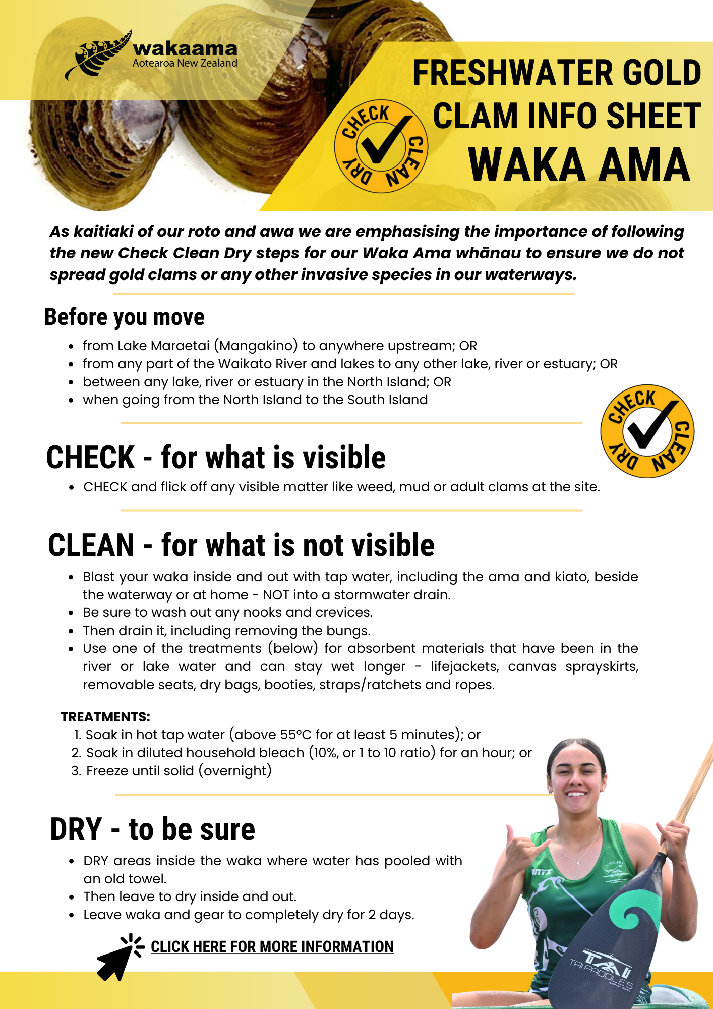
https://www.mpi.govt.nz/biosecurity/exotic-pests-and-diseases-in-new-zealand/pests-and-diseases-under-response/freshwater-gold-clam/
Process undertaken by Ruamata Waka Ama Club:
Pre-Event Comms:
• Share appropriate Biosecurity NZ info about Clams and Te Arawa Lakes specific CCD procedures via our communication channels – Facebook, emails to participants and the Waka Ama NZ event site Pānui.
• Share Rotohoe/Rotorua/Te Arawa Lakes generated Clam specific plan (details in this plan) with clubs wishing to enter the event.
• A waiver will be sent to all participants when requesting an entry form which will include the ‘Clam specific CCD’ requirements for entry acceptance to our event and specific techniques for cleaning equipment.
• This waiver will be signed acknowledging that all ‘Clam specific CCD’ processes will be adhered to and received prior to the event day along with the entrance fee.
• Liaise with TALT representative who will be present on event day to advise and educate.
• We will hold a record of Comms sent out to participants.
Late Entries
• As some of the ‘Clam specific CCD’ takes a minimum of 3 days there will be no late entries.
Registration
• Confirmation at check-in that participants have followed ‘Clam specific CCD’ including the signed waiver.
• No signed waiver means no entry to event.
• TALT representative will be present to assist and discuss options.
Race Briefings/Prizegiving
• Include Clam CCD information at race briefings. TALT representative present at race to inform/educate.
Post Event CCD
• Reminders that Lake Rotorua has invasive species present (i.e. catfish) and is high risk for a clam incursion, so ‘Clam specific CCD’ must be used on exit from Rotorua.
• Provide Clam updates to your sporting community in between events.
Post Event Assessment
• Club member comments on CCD at your event to be reviewed - what worked well, what could be improved? Attitude of participants.
• Allow TALT to edit and add any comments/improvements.

